

Watershed Preservation Network

PO Box 8, San Geronimo, CA 94963 ~ Ph: 415 488-9341 Fax: 415 488-0262

November 23, 2007

Watershed Preservation Network (WPN) is a 501c3 non-profit organization serving Northern California. Our focus is on environmental education, conservation, advocacy, and networking and technical support for other non-profit organizations.

Environmental advocacy is a cornerstone of WPN: we conduct environmental investigations to protect the public and environmental health and we offer experienced consultation to the public and other non-profit groups on scientific investigation and recourses related to environmental issues and situations.
We also analyze and comment on selected legislation and policy-development.

WPN participates in a wide variety of restoration and preservation projects: fisheries enhancement, habitat restoration, bank stabilization, water quality monitoring, open space preservation, wetland protection, wildlife corridors and creek and bay issues.

WPN’s environmental education programs include in-school workshops for public and private schools, and adult and teacher training, specializing in the integration of environmental sciences, natural history, and the arts. WPN programs are specifically designed to reintroduce the natural world to our students in a fun, scientific, and culturally meaningful way; to encourage curiosity and promote integrated learning.

In WPN’s advocacy work, WPN is dedicated to using the public process in the most effective ways possible to protect the environment and public health. Similarly, WPN works to support a full and healthy public process. Essential resources for WPN’s work include the California Environmental Quality Act (CEQA), California’s Brown Act, and the National Environmental Quality Act (NEPA), and other environmental laws that support complete and transparent public process.

For many years, in our advocacy efforts, WPN has relied heavily on CEQA and NEPA documents to evaluate the environmental appropriateness and completeness of various projects. Without full and complete public disclosure of a proposed project’s impacts, WPN and WPN’s constituents are left with no way to gather information to analyze proposals and participate in the public process.

Specifically related to the North Coast Rail Authority (NCRA) proposal to reinstate freight trains from Humboldt Bay/Eureka through the Eel River Canyon (including Island Mountain Quarry) south through Willits to Lombard, WPN already has noted causes for serious concerns. The northern reaches of the proposed freight project
include environmentally sensitive habitat, extremely fragile geologic areas, and a designated Wild and Scenic River. The entire route hosts a variety of threatened and endangered California and Federally listed species. In addition, in a number of

instances, the route crosses through wetlands, including those in the Pacific Flyway. Construction, repairs, and freight operation through all of these areas will inevitably cause environmental impacts, the extents of which are yet unknown. The only way to assess these impacts and ensure minimal damage is through comprehensive State and Federal Environmental Impact Reviews, and an inclusive, responsive, and transparent public process.

CEQA requires full disclosure of an entire project: the environment does not recognize man-made geographical boundaries or project “phases.” However, NCRA’s own documents (Strategic Plan - Calif. Transportation Commission) have admitted that NCRA freight service in Sonoma County alone, would not be economically viable. Also, the NCRA’s policy from 2001 stated its “fundamental goal is the re-establishment” of freight service from Humbolt Bay to Lombard. Taken together, these NCRA statements of intent clearly signify ONE project, not three.

Additional documents and statements to the press show that NCRA plans imminent continuation of the rail line from Sonoma up to Humbolt Bay; these plans would fall outside the scope of the Sonoma to Lomabard environmental impact reports. The result is that the environmental impact assessment studies for work within the Sonoma-Marin area would represent a segmentation of the environmental review. The entire project cannot feasibly be accomplished without additional segments that will not be included in the limited scope of environmental impact reviews for the Willits to Lombard segment.

Therefore, it is our position that NCRA must assess the entire project’s cumulative environmental impacts from North endpoint (Humbolt Bay) to South endpoint (Lombard), and include a complete scope of impacts for the project.

Sincerely,
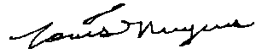
Louis Nuyens, President

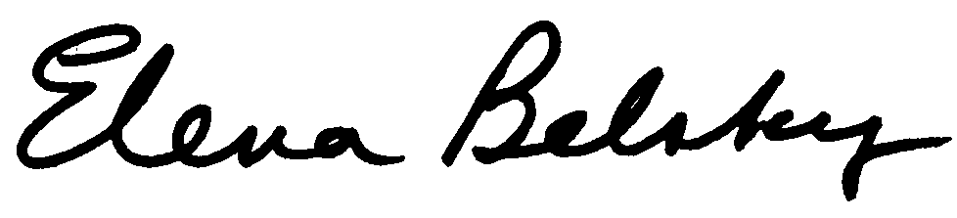
Elena Belsky, Director

